***I. Choose the word / phrase / sentence (A, B, C or D) that best fits the space or best answers the question given in each sentence.* (3.5 pts).**

**1.** Which word has the underlined part pronounced differently from that of the others?

**A.** t**ea** **B.** d**ea**f **C.** l**ea**ve **D.** l**ea**d

**2.** Which word has the underlined part pronounced differently from that of the others?

**A.** sou**th**ern **B.** grow**th** **C.** wi**th**in **D.** al**th**ough

**3.** Which word has a different stress pattern from that of the others?

**A.** excellent **B.** different **C.** finally **D.** fantastic

**4.** Which word has a different stress pattern from that of the others?

**A.** effect **B.** event **C.** emerge **D.** even

**5.** The weather ______ predicts sunny skies and warm temperatures for the weekend.

**A.** forecast **B.** predicting **C.** estimate **D.** guessing

**6.** The number of kids in the neighborhood ______ over the past few years.

**A.** have grown **B.** has grown **C.** is growing **D.** are growing

**7.** She ______ back to her hometown since she was 10.

**A.** didn’t come **B.** not come **C.** hasn’t come **D.** doesn’t come

**8.** The volunteers willprovide food and shelter for the ______ during the winter months.

**A.** homesick **B.** homeless **C.** homeland **D.** homework

**9.** The teacher, ______ everyone admired, encouraged her students to pursue their passions.

**A.** whom **B.** which **C.** whose **D.** what

**10.** Her constant ______ helped him gain the confidence to pursue his dreams.

**A.** suggestion **B.** politeness **C.** encouragement **D.** growth

**11.** The training session provided instructions on how ______ the equipment safely and efficiently.

**A.** operated **B.** operating **C.** operate **D.** to operate

**12.** **Amy**: - "Would you mind bringing the documents to Mrs. Swift?"

**Mark**: - “______.”

**A.** He wouldn't mind anything. **B.** I would never do it if I were you.

**C.** No, I can handle it myself. **D.** Sure, I'll do it now.

**13. Hanh: -** “I can’t thank you enough for your support during this tough time!”

**Quan: -** “______.”

**A.** I'm glad you supported me. **B.** Thanks a million for your help.

**C.** That was the least I could do. **D.** You can say that again.

**14.** The scientists are ______ tests to determine the effectiveness of the new drug.

**A.** taking over **B.** carrying out **C.** calling up **D.** making up

***II. Look at the sign or the notice. Choose the best answer (A, B, C or D) for questions 15 and 16*. (0.5 pt)**

**15**. What does the sign say?



**A.** Drivers should slow their speed as the road is wet or icy.

**B.** There is a car accident on this slippery road.

**C.** Drivers should increase their speed to avoid slippery roads.

**D.** You mustn’t drive a car on a slippery road.

**16.** What does the notice say?

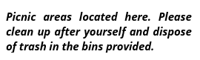

**A.** You can leave trash in the picnic areas.

**B.** You have to bring the trash home with you.

**C.** You should clean yourself before going to the picnic areas.

**D.** You should collect the trash and throw it in the dustbins.

***III. Choose the word (A, B, C or D) that best fits each space in the following passage*. (1.5 pts)**

Millions of people love the sport of basketball in the United States and around the world, but few people stop to think about who (17) ______ it, why, where and when. It was James Naismith, a (18) ______ at the YMCA in Springfield, Massachusetts. Naismith was tasked with creating an indoor sport to keep his students (19) ______ during the cold winter months. The rule was simple: players had to throw a soccer ball (20) _____ the opposing team's basket to score points. Naismith believed that basketball was (21) ______ than football. The very first game of basketball was played on December 21, 1891 when James asked his college class to play a new kind of game. His students weren’t very excited about this strange new sport, (22) ______ they played anyway. Basketball later became an international sport and the person we have to thank for this amazing sport is James Naismith!

**17. A.** invented **B.** invent **C.** invents **D.** inventing

**18.** **A.** physics education teacher **B.** education physical teacher

**C.** physical education teacher **D.** physical education teaching

**19. A.** actively **B.** active **C.** activate **D.** inactive

**20. A.** into **B.** out of **C.** from **D.** inside

**21.** **A.** more safer **B.** more safety **C.** safer **D.** safest

**22.** **A.** although **B.** but **C.** so **D.** and

***IV. Read the following passage. Decide whether the statements from 23 to 26 are True or False and choose the correct answer (A, B, C or D) to complete the statements in the questions 27 and 28.* (1.5 pts)**

The Olympics are a major international sports event. It happens every two years in the summer and then in the winter. Many countries want to host the Olympics, but it is a very difficult event to organize. Countries have to construct new buildings and make old buildings more modern. However, it can give an old city a new life and improve the city as well as make a lot of money. Atlanta, Georgia, in the USA, made $300 million from the 2004 Olympics.

The Spanish city of Barcelona is more than 2000 years old. It has many fantastic old buildings and is famous for the architect, Gaudi. His unusual stone and brick buildings are all across the city. Since the 1992 Olympics, you can also see many modern buildings in the city.

The Olympic port was an ugly, old area of Barcelona. There wasn't a nice beach in the city, but now there is a wonderful man-made beach. As part of the preparation for the games, industrial buildings along the sea were demolished and 2 miles of beach were created. Before the Olympics, there were many huge, ugly concrete and glass hotels. However, construction workers made the old hotels more modern, and today Barcelona is the twelfth most visited city in the world!

**23.** Few countries want to organize the Olympics because it’s a challenging task.

**24.** Hosting the Olympics can transform a city and bring in a big sum of money.

**25.** Gaudi is known for his traditional building styles using stone and concrete.

**26.** Modern buildings in Barcelona have appeared since the 1992 Olympics.

**27.** What change occurred in Barcelona due to the 1992 Olympics?

**A.** The city built a new airport to welcome more tourists.

**B.** It added many modern buildings and a man-made beach.

**C.** It closed down all concrete and glass hotels.

**D.** The number of construction workers increased.

**28.** What is the main idea of the reading passage?

**A.** Barcelona is a beautiful city for people to visit all year round.

**B.** Hosting the Olympics can make a lot of money for a country.

**C.** Barcelona is a typical example of benefiting from hosting the Olympics.

**D.** Barcelona and Atlanta made a lot of money thanks to the Olympics.

***V. Use the correct form of the word given in each sentence.* (1.5 pts)**

**29.** She made a deep ______ on the members of the club. **(impress)**

**30.** My sister is wearing a T-shirt of the latest model. She always dresses ______.**(fashion)**

**31.** The ______ office was filled with dust and forgotten papers. **(occupy)**

**32.** The finishing time is a bit ______, it depends how things go. **(predict)**

**33.** TV ______ are advertisements in which goods and services are promoted. **(commerce)**

**34.** He was **______** recognized for his contributions at the awards ceremony. **(office)**

***VI. Look at the entry of the word 'effect' in a dictionary. Use what you can get from the entry to complete the sentences with two or three words*. (0.5 pt)**

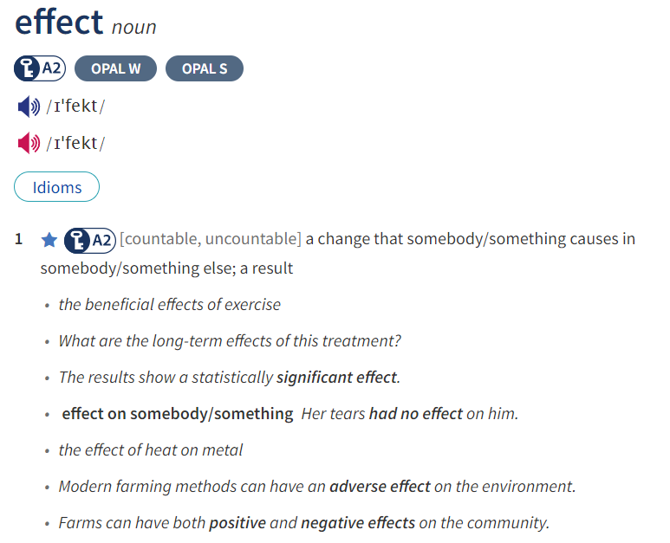

**35.** ______ of social media on mental health are becoming more widely recognized.

**36.** The teacher's warning ______ on the students and they continued to chat during class.

***VII. Rewrite each of the following sentences in another way so that it means almost the same as the sentence printed before it*. (1.0 pt)**

**37.** It is a narrow road. It’s difficult for two cars to pass each other.

➜ The road is too ____________________________________________________________________.

**38.** They passed their final exam because they studied hard.

➜ Because of __________________________________________________________________________.

**39.** “It was nice of you to invite me to your dinner. Thank you”, Mrs. Lan said to Tuan.

➜ Mrs. Lan thanked ___________________________________________________________________.

**40.** Leave me alone, or I will call the police.

➜ If you ________________________________________________________________________________.